Wireless Light Switcher

SE Practicum - Project Plan

Group 9

* 13304010 – Andrew Sebastian
* 14309003 - Jang Soon Myun
* 14309002 - Jin Kwang Un
* 14309001 - Park Geun O
* 13304011 - Hassan
* 13304013 - Vincent

Wireless Light Switch

Table of Contents

|  |
| --- |
| 1. Project Chartering …………..……………………..……………………………………………….… 2 |
| 1.1 Objectives ……………….………………………………………………………………………….. 2 |
| 1.2 Context .…………….……………………………………………………………………………….. 2 |
| 1.3 Our Project .….…………..………………………………………………………………………… 2 |
| 2. Value Definition & Roadmap ....…………………………………………………………………. 3  2.1 Area(s) of Impact ………………………………………………………………………………….3  2.2 Potential Value of IT Solution ……………………………………………………………... 3 |
| 2.3 Roadmap …………………………………………………………………………………………….. 3 |
| 2.4 Prototype Timeline Summary ……………………………………………………………… 4 |
| 3. Architecture ……………………………………………………………………………………………….. 5 |
| 3.1 Platform Architecture ………………………………………………………………………….. 5 |
| 3.2 System Architecture Design …………………………………………………………………. 6 |
| 4. Feature Priority Identification …………………………………………………………………….. 7  4.1 Feature Value Comparison …………………………………………………………………… 7 |
| 4.2 Customer Satisfaction …………………………………………………………………………… 7 |
| 4.3 Feature Priority …………………………………………………………………………………….. 8 |
| 5. Initial Product Backlog ………………………………………………………………………………… 8 |
| 5.1 Product Backlog ……………………………………………………………………………………. 8 |
| 5.2 Acceptance Criteria ………………………………………………………………………………. 9 |
| 6. Initial Sprint Backlog & Release Plan …………………………………………………………… 10 |
| 6.1 Initial Sprint Backlog …………………………………………………………………………….. 10 |
| 6.2 Release Plan …………………………………………………………………………………………. 11 |
| 7. Quality Plan ………………………………………………………………………………………………… 11 |
| 7.1 Definition of Ready ………………………………………………………………………………. 11 7.2 Definition of Done ………………………………………………………………………………… 12 |
| 8. Test Strategy ……….……………………………………………………………………………………… 13 |
| 8.1 Test Environment ………..………………………………………………………………………. 13 |
| 8.2 Requirements for test ………..………………………………………………………………… 13 |
| 8.3 Testing Types ……………………..………………………………………………………………… 14 8.4 The 4 quadrants ……………………..…………………………………………………………… 15 |

1. Project Chartering

1.1 Objectives

While this concept is quite popular in developed countries, other developing countries may not still familiarize. The fact is that the cost of production of these devices is high because of lack resources. Some product may have many features but also high in price. Therefore, we have objectives:

* Popularized home automation/ Smart home concept.
* Create room integration with simple steps.
* Provide affordable product in the market.
* Accessible, stable, and secure smart phone.

1.2 Context

* + Home Automation

Smart Homes, also known as automated homes, intelligent buildings, integrated home systems or domotic, are a recent design development. Smart homes technology uses many of the same devices that are used in assistive technology to build an environment in which many features in the home are automated and devices can communicate with each other.

* Internet of things

The term “Internet of Things” collectively describes technologies and research disciplines that enable the internet to reach out the real world of physical objects. Technologies like short-range wireless communications, real-time localization, and sensor networks are becoming increasingly pervasive making the IoT a reality. IoT grows in many sectors like environmental, logistics, public safety and so on.

1.3 Our project

We will apply the 2 concept into our projects by using light switch as the media. The idea is to control the light switcher using smart phones application (Android platform) by signaling the Bluetooth receiver in our device. With programmed chipset inside which will send command to move the switch into desireable position.

2. Value Definition & Roadmap

2.1 Area(s) of Impact

Area of impact is China region focusing on Beijing city. Our targets consist of business industries for example restaurants and KTV, and local family. Also other sector like hospitally such as hotels, inns and apartements.

2.2 Potential Value of the IT Solution

Compare to other products, ours is considerably cheaper and focus on one feature. This feature fulfills the main purpose of the product and possibly is enchanced into greater and more added feature. Customer will not be confused by using our product because we provide friendly UI application to control the switch.

2.3 Roadmap

Using agile project management, we decide to make the prototype in both hardware and application. The first practice is analyzing customer demand and comparing business scale of other similar product in the market. From this on, we able to perceive errors that should be fixed and future improvement. In schedule, we will have completed the product after 2 years of development.

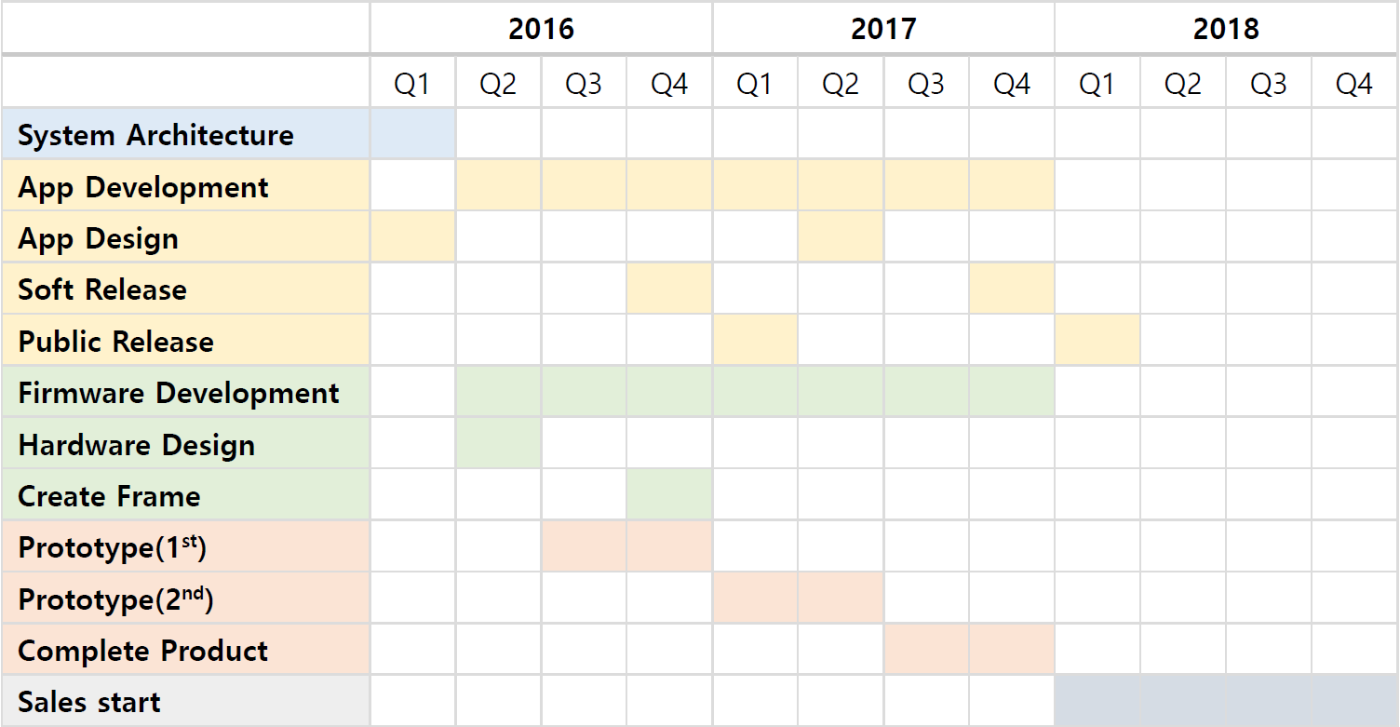

Roadmap

2.4 Prototype Timeline Summary

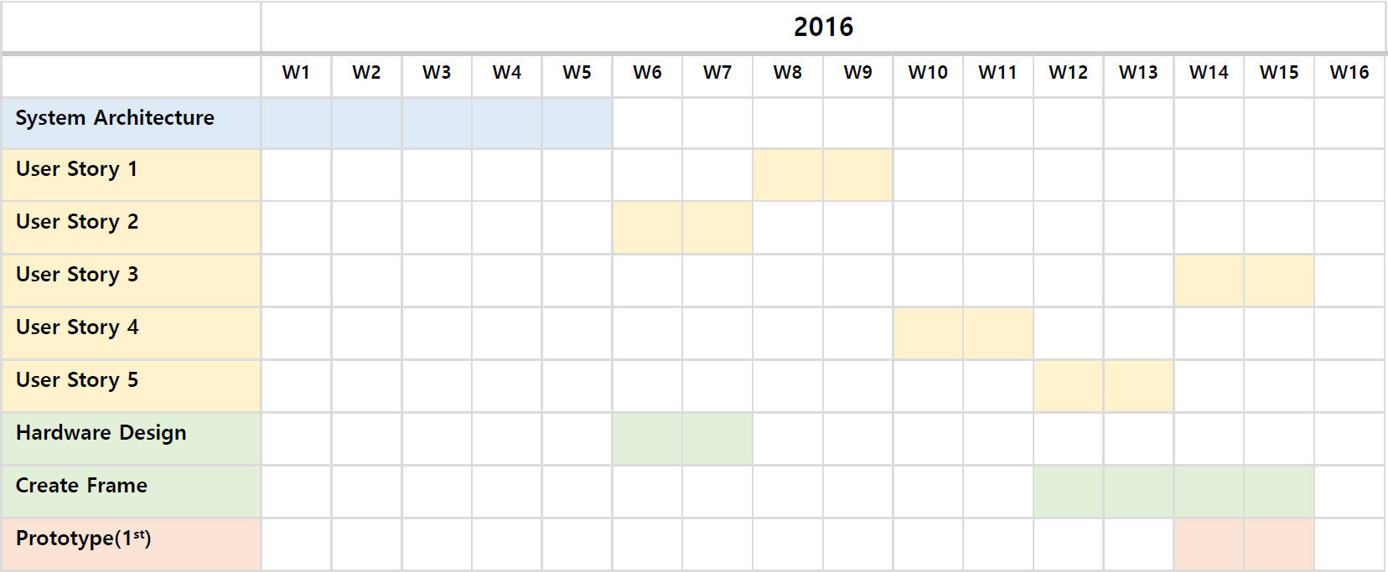

3. Architecture

3.1 Platform Architecture

The product service consists of 3 parts:

* Switch ability, turning the switch into the desirable position using wireless element. User does not have the need for physical contact with the switch.
* Scheduling time, setting up alarm and configure the live-time for the light. We consider this feature to be beneficial for user that can not sleep without light but also want to save electricity.
* Dashboard, on this feature user can list switch that is controlled using the application and see the status of it.

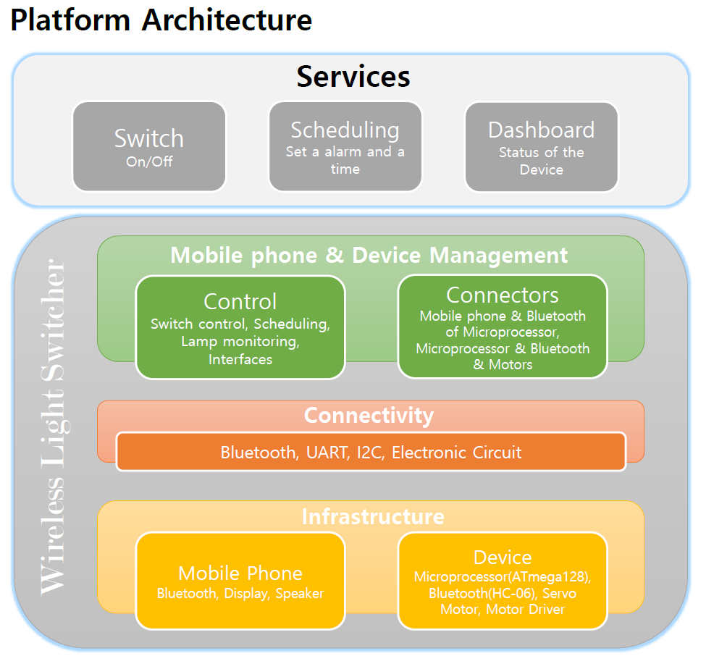

3.2 System Architecture Design

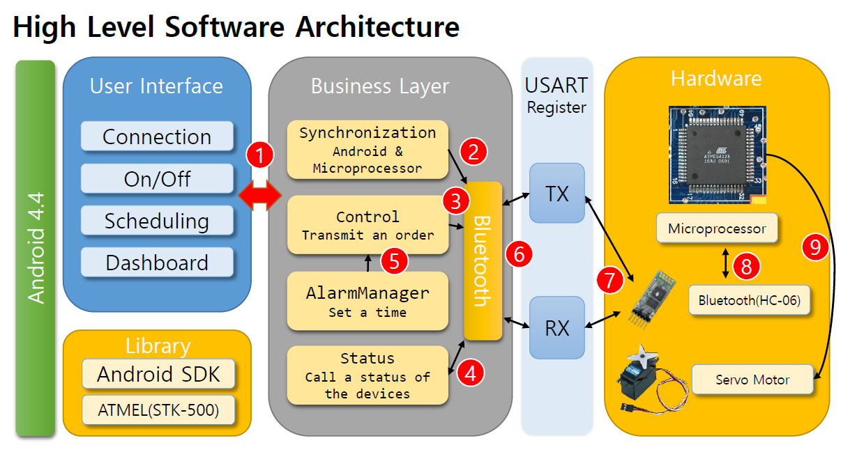

Process Track:

1. User can choose 4 functions.  
   - Connection: The connection between the Bluetooth of Android and the Bluetooth of Device  
   - On/Off: You can turn on or off the lamp switch.  
   - Scheduling: You can set alarm.  
   - Dashboard : You can see the status of the Light Switcher
2. Transmit the command of synchronization with Bluetooth of Device to Bluetooth.
3. Transmit the command to turn on/off the Light Switcher to Bluetooth.
4. 1) Transmit the command to see the status of the devices to Bluetooth.  
   2) Receive the status of the devices from Bluetooth.
5. 1) Set a time in the mobile phone.  
   2) When the alarm is running, execute the function of turn on the Light Switcher.
6. Transmit or receive the commands to USART Register in the Bluetooth device.
7. Equal to no.6
8. Transmit or receive the commands to the Microprocessor.
9. If the Microprocessor received the commands to turn on/off, the Servo motor will work.

4. Feature Priority Identification

4.1 Feature value Comparison

|  |  |  |
| --- | --- | --- |
| Feature | Our Product | Other Product in China |
| Interface | We will implement user friendly interface based on android application. | Most of other product does not have application as the controller; instead they provide built-in remote control. By providing extra remote will increase the production cost |
| Connectifity | Using bluetooth protocol, the range of our product is about the size of studio room, which is ideal for private user. | Different throught brand. |
| Service | Our product has main focus feature and additionals that increase the variaty of function. We will make sure there will be no bug. In case it exists, our developer team can find the solution and update the software. | It almost impossible to ask for solution to the maker if user find any disfunctionality. The quality of the product mostly is decided through customer rating. |
| Usability | There will be no confusing button or tabs in the application. | They provide basic needs. |
| Installation | User can install our product by himself, only a few steps to complete the installation. | Based on manual. |

4.2 Customer Satisfaction

At the initial sale phase, our product may no really popular in the market. We will device plan to promote the product using such method like advertising and register the product to online shopping website. As more customers purchase the product, they will give opinions and critics. We will relying on survey of customer satisfaction rate and see this as a room for improvement. By analyzing the survey, the product will go through more iteration and updates as one of goal is providing best product condition.

4.3 Feature Priority

|  |  |
| --- | --- |
| Feature | Priority |
| Interface | Medium |
| Connectifity | Medium |
| Service | High |
| Usability | High |
| Installation | High |

5. Initial Product Backlog

5.1 Product Backlog

|  |  |  |  |
| --- | --- | --- | --- |
| ID | User Story | Estimation | Priority |
| 2 | As a Product Owner I want the switch device to receives signal and turn on/off the light | 2 weeks | 1 |
| 1 | As an User I want my application to control the light switch | 2 weeks | 2 |
| 4 | As an User I want my application to automatically connect to Bluetooth | 2 weeks | 3 |
| 5 | As an User I want to schedule light live-time | 2 weeks | 4 |
| 3 | As an User I want swipe the control button on my application | 2 weeks | 5 |

5.2 Acceptance Criteria

In constructing the criteria, the team develops a shared understanding of the user story and its scope. Each item provides a hint of one or more tasks that a team member will need to do to accomplish the sprint.

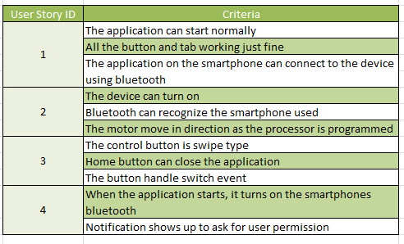

As work on a user story begins to wrap up, the team circles back to the acceptance criteria, reviewing each and checking that it has been met. I find it’s a good idea for the team to focus particular attention on acceptance criteria during Sprint review.

6. Initial Sprint Backlog & Release Plan

6.1 Initial Sprint Backlog

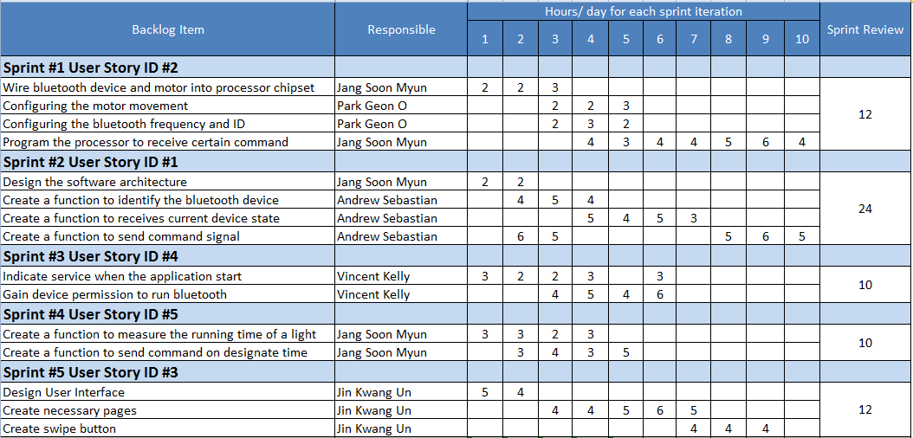

6.2 Release Plan

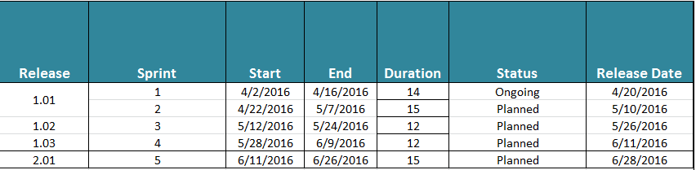

First version of the release is indicated as protoype, while the second version will be the public release. It contains all the functionality and stable for user use.

7. Quality Plan

7.1 Definition of Ready (DoR)

|  |
| --- |
| The business value is clearly articulated. |
| The story follows the INVEST(Independent, Negotiable, Estimable, Small and Testable) model |
| The story can be completed in one sprint. |
| The story has clear and concise acceptance criteria |
| Once the acceptance criteria have been met the story is complete. |
| Acceptance criteria are clear and testable. |
| No external dependencies block the story being completed. |

7.2 Definition of Done (DoD)

|  |  |
| --- | --- |
| User Stories | * All Acceptance Criteria of the User Story are met. * All critical and major issues detected in code review. * User documents completed and checked all. * Code peer reviewed (if not pair programmed). * The code is covered by a minimum of 70% Unit Tests and all tests are Green. * Integration tests of the affected areas are conducted and passed. |
| Sprints | * All the User Story included in the Sprint are closed and meet the User Stories DoD. * All Unit Tests, Automated Acceptance tests have passed successfully. * The agreed development freeze day has been met. * Regression testing has been performed on the product after the changes. * No Critical or Blocker bug exists in the bug backlog. |
| Field Release | * A backup has been made. * The software is base-lined and released. * Make sure the product is tested and the configuration changes are ready. * The possibility of rollback with related risks has been provided. |

8. Test Strategy

8.1 Test Environment

|  |  |
| --- | --- |
| **H/W & S/W** | |
| PC | Samsung Laptop |
| Processor | Intel® Core(TM) i7-2675QM CPU @ 2.20GHz |
| Microprocessor | ATmega128 |
| RAM | 8.00GB |
| System kind | 64bit |
| OS | Window 7 Home Premium K |
| Tool | AVR Studio, Eclipse, Android studio |
| Component | Servo motor ,Bluetooth |

8.2 Requirements for test

* **Function Testing**
  + Verify auto Bluetooth signal connection
  + Verify timer function
  + Verify swipe function
* **User Interface Testing**
  + Real time Turn on / off display to confirm the conditions
  + Bluetooth connection is fast and reliable.
* **Configuration Testing**
  + Verify connection between microprocessor and application.
  + Verify connection between microprocessor and motor.

8.3 Testing Types

* **Function Testing**

Testing of the application should focus on any target requirements that can be traced directly to use cases (or business functions), and business rules. The goals of these tests are to verify proper function implementation, and the appropriate implementation of the business rules. This type of testing is verifying the application by interacting with the application via the GUI and analyzing results.

* + Test Objective: Ensure application satisfies customer requirements, and industry standards.
  + Technique:
    - * Execute each use case, use case flow, or function, using valid and invalid data, to verify the following:
      * device receives signal and turn on/off the light
      * application automatically connect to Bluetooth
      * Able to set schedule timer
      * lights turn on when time is reached
      * swipe function correctly turn on / off light
  + Completion Criteria:
    - * All planned tests have been executed.
      * All identified defects have been addressed.
* **User Interface Testing**

User Interface testing verifies a user’s interaction with the software. The goal of UI Testing is to ensure that the User Interface provides the user with the appropriate access and navigation through the functions of the applications. In addition, UI Testing ensures that the objects within the UI function as expected and conform to corporate or industry standards.

* + Test objective - verify the following
    - * Navigation through the application properly reflects business functions and requirements, focusing on simple and useful design with swipe function.
      * Bluetooth connection is fast and reliable.
  + Technique:
    - * Create / modify tests insuring when this application runs on the android device it invokes the Bluetooth interface.
      * Create / modify tests to check swipe function complete task of turning on and off the light .
  + Completion Criteria :
    - Each window successfully verified to remain consistent with benchmark version or within acceptable standard.
* **Configuration Testing**

Configuration testing verifies connection and operation of the software and hardware components. The microprocessor's connection to both the app and the motor is critical to the successful function of the product.

* + Test Objective
    - * Verify the connection between the various hardware and software components are established and meet industry standards and acceptance criteria.
  + Technique:
    - * Motor control using a microprocessor in the desired direction
      * The button operation of the hardware in mobile phones
  + Completion Criteria
    - * Connection between microprocessor and application is reliable.
      * Connection between microprocessor and motor reliable.

8.4 The 4 quadrants

For test planning, we will base our planning on Agile Testing Quadrants and keeping in mind the success of the project relies on a very collaboration between all members of the team. Testing is the responsibility of the team, not only to test engineers working in the team.

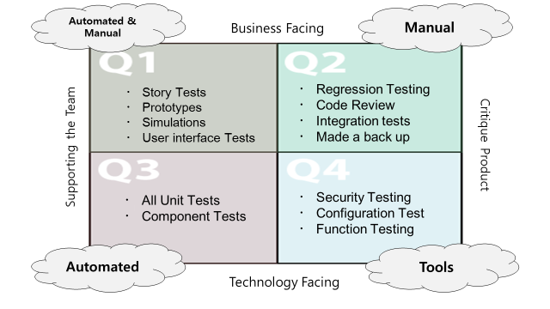

8.5 Pyramid of tests

